**DBMS Assignment 4**

**Hospital Bed database during Covid**

The database is written and executed in PostgreSQL. The front end is written in python is executed through the command prompt. From our learnings in python application programming, we will be using certain methods such as connect() for example to establish a connection between the SQL database and the python application. The front end is a simple menu-based method to choose and execute queries.

This database is specifically made for Covid situations for the time when beds were required in large numbers. Several factors such as covid test results, temperature, and severity were considered which is not done usually in non-covid periods. The table waiting would not be required since there wouldn’t be such a thing in usual times. Hence the application needs to be changed, certain attributes and entities would no longer be required. Constraints would change and so would the schema. DBMS need not be migrated however there could be changes in the front end and limitations as to what the user can see.

Of the four major NoSQL databases, if the current database needs to be migrated, we would choose a document-based database. Hospital databases are usually separated patient-wise. Hence a document-based NoSQL database would be easier to manage. Column-oriented NoSQL is separated attribute-wise. It would be suitable in case there are any new attributes added to the database which is not a situation in our database. Key-value NoSQL database uses the key pair method which won't be useful here. Graph base NoSQL would not be a good fit for admins to access and understand the data.

Contribution:

Anjali Praveen ( PES2UG19CS047 ): Front end using python. Report. 1 hour.

Anusha M S ( PES2UG19CS055 ): Connectivity and testing. Report. 30 mins.

Apurva Pothumarthi ( PES2UG19CS060): Front end using python. Report. 1 hour.

**SCREENSHOTS**

PATIENT

1. Homepage

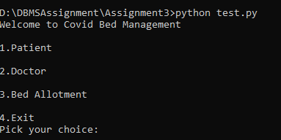

1. Listing all the patients

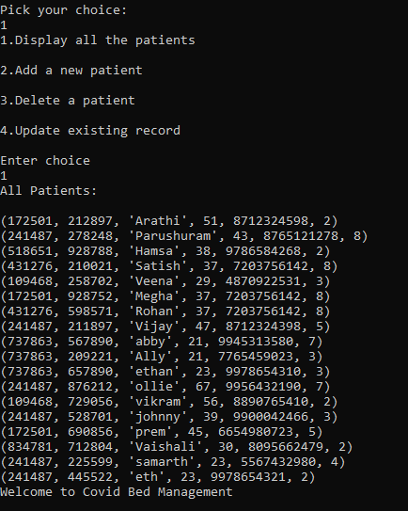

1. Adding a new patient

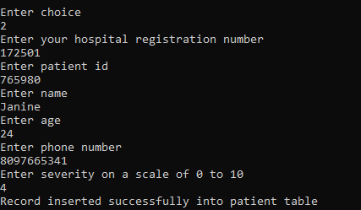

1. Updating patient details

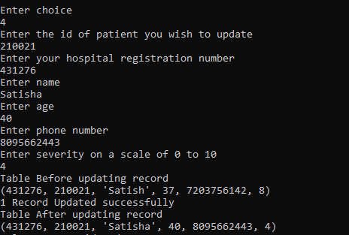

DOCTOR

1. Displaying the doctors

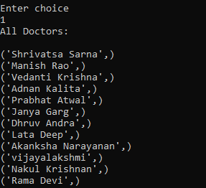

1. Deleting a doctor

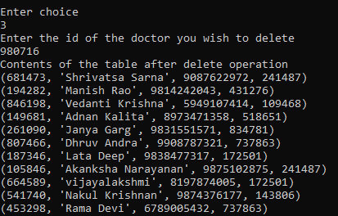

1. Prescribing medicines

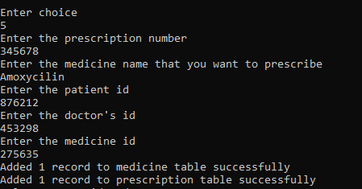

BOOKING BED

1. Seeing availability

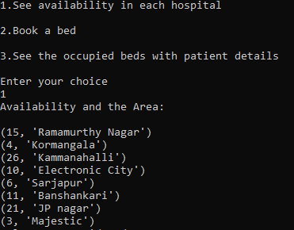

1. Booking based on availability

